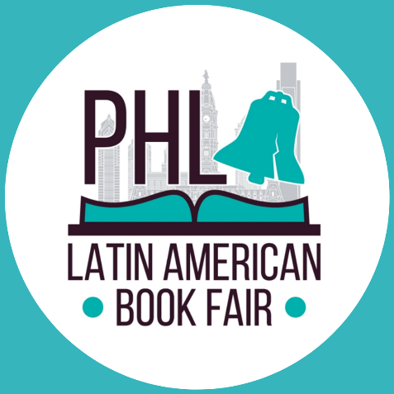

Sponsor Company Name: _____________________________________________

Address: _______________________________________________________________
City: __________________________ State: _________________ Zip Code: _________
Phone: ____________________________ Website: ____________________________
Event Contact: __________________________________________________________
Contact Phone: ________________________ Contact email: _____________________

□ $2,000 Title Sponsor - Exclusive Presenting Sponsor
□ $500 - Gabriel García Márquez Package
□ $350 - Isabel Allende Package
□ $150 – Pablo Neruda Package

Please make checks or money orders payable to:
Accion Colombia
Memo line: Your sponsor level / LABF 2020

Mail to:
Latin American Book Fair - Leity Rodriguez
4636 N 5th Street Philadelphia, PA 19140

You can also purchase a sponsorship package by clicking the following link:
https://www.eventbrite.com/e/latin-american-book-fair-feria-del-libro-latinoamericano-tickets-121856154037

Client Signature: _________________________

Date: ________________
Payment due with signed contract

Sponsorship registration and logo must be received by September 28th in order to be included!
philaferiadellibro@gmail.com

